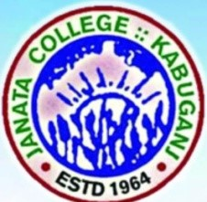
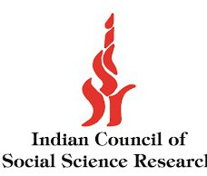ICSSR Sponsored Two Day National Seminar on
Reversing the Western Gaze: Rediscovery and Resurgence of the Idea of Bharat
24th& 25th January, 2025
Janata College, Kabuganj, Cachar, Assam-788121

Seminar Report

The Department of English at Janata College, Kabuganj organized ICSSR sponsored a two day National Seminar on 24 and 25 January, 2025 themed “Reversing the Western Gaze: Rediscovery and Resurgence of the Idea of Bharat”. Prof. Rajive Mohan Pant, honorable Vice Chancellor of Assam University, Silchar graced the inaugural session as the Chief Guest and illumined the audience with his valuable insights. Dr. Suprabir Duttaroy, Controller of Examinations of Assam University was the Guest of Honour who addressed the audience with his valuable speech. Professor Dipendu Das, former Dean and Professor of English of AUS, delivered an insightful keynote speech on the topic “Macaulay’s Ghost, Politics of Gaze, the Idea of Bharat and Contemporary India". A galaxy of resource persons were present in person and contributed in generating meaningful dialogue on the theme. The organizing committee extended heartfelt thanks to Prof. Anindya Syam Choudhury, Prof. Saugata Kumar Nath, Prof. Niranjan Roy, Prof. Suparna Roy of AUS, and Prof. Veenu Pant of Sikkim Central University, Dr. Lipika Roy of Tripura University, and Dr. Nilanjan Dey of R S Girl's College, Sribhumi for their valuable contributions. The Valedictory session was addressed by the Principal of the college, Dr. Debasish Paul.

The important point that emerged from this seminar is that in order to know Bharat we need to understand its geo-cultural history and not simply the geopolitical aspects. It is a sacred land having a cultural legacy of time immemorial that should have to be explored and fore grounded to construct a true idea of Bharat for the future generations. How India and Bharat bear distinctly different connotations to a greater extent is revealed in the discussions. India may be a nation- state born in the year 1947, but Bharat carries with it the fragrance of the oldest civilization of the world. We are not the people of India but the children of this land called Bharat and this is referred to in the ancient text like Vishnupurana. Bharat had its own calendar even when the West could not think of it. The massive distortion with the history due to the Western intervention is also highlighted again and again. The papers presented in the two day academic gathering revealed the diverse aspects of Bharat including its rich tradition of Performing Arts, its culture of Women Worship as Shakti, the Environment consciousness that are ingrained in the Vedic texts, etc. More than thirty participants from different parts of the country actively presented their papers exploring the different aspects related to the theme. Apart from the paper presenters, the students of the college also participated in great number and engaged themselves in compèring, rapporteuring, and interacting on different topics delivered in the event.


Seminar Coordinator

